# File permissions in Linux

## **Project description**

## Examine existing permissions on the file system. determine if the permissions match the authorization that should be given. If they do not match, modify the permissions to authorize the appropriate users and remove any unauthorized access.

## **Check file and directory details :**

1. Command : ls -la to check all the docs and dirs. (even the hidden one)

Figure 1

* The 10 character string represents the file permissions
* First represents the fact that the specific “file” is a directory or not
* The 3 after that represent the User permissions
* The 3 after the user permissions represent the group permissions
* And the 3 last represent the permission of other users.

1. We need here to change the permissions of the project_k.txt because it grants the other users the write permissions, to do this, we’ll use the command :

* Chmod o-w project_k.txt

Figure 2

## Change file permissions on a hidden file

1. We also need to change the file permissions on the hidden file named “.project_x.txt”, the file .project_x.txt is a hidden file that has been archived and should not be written to by anyone. (The user and group should still be able to read this file.)

Here, we will use another time the chmod command.

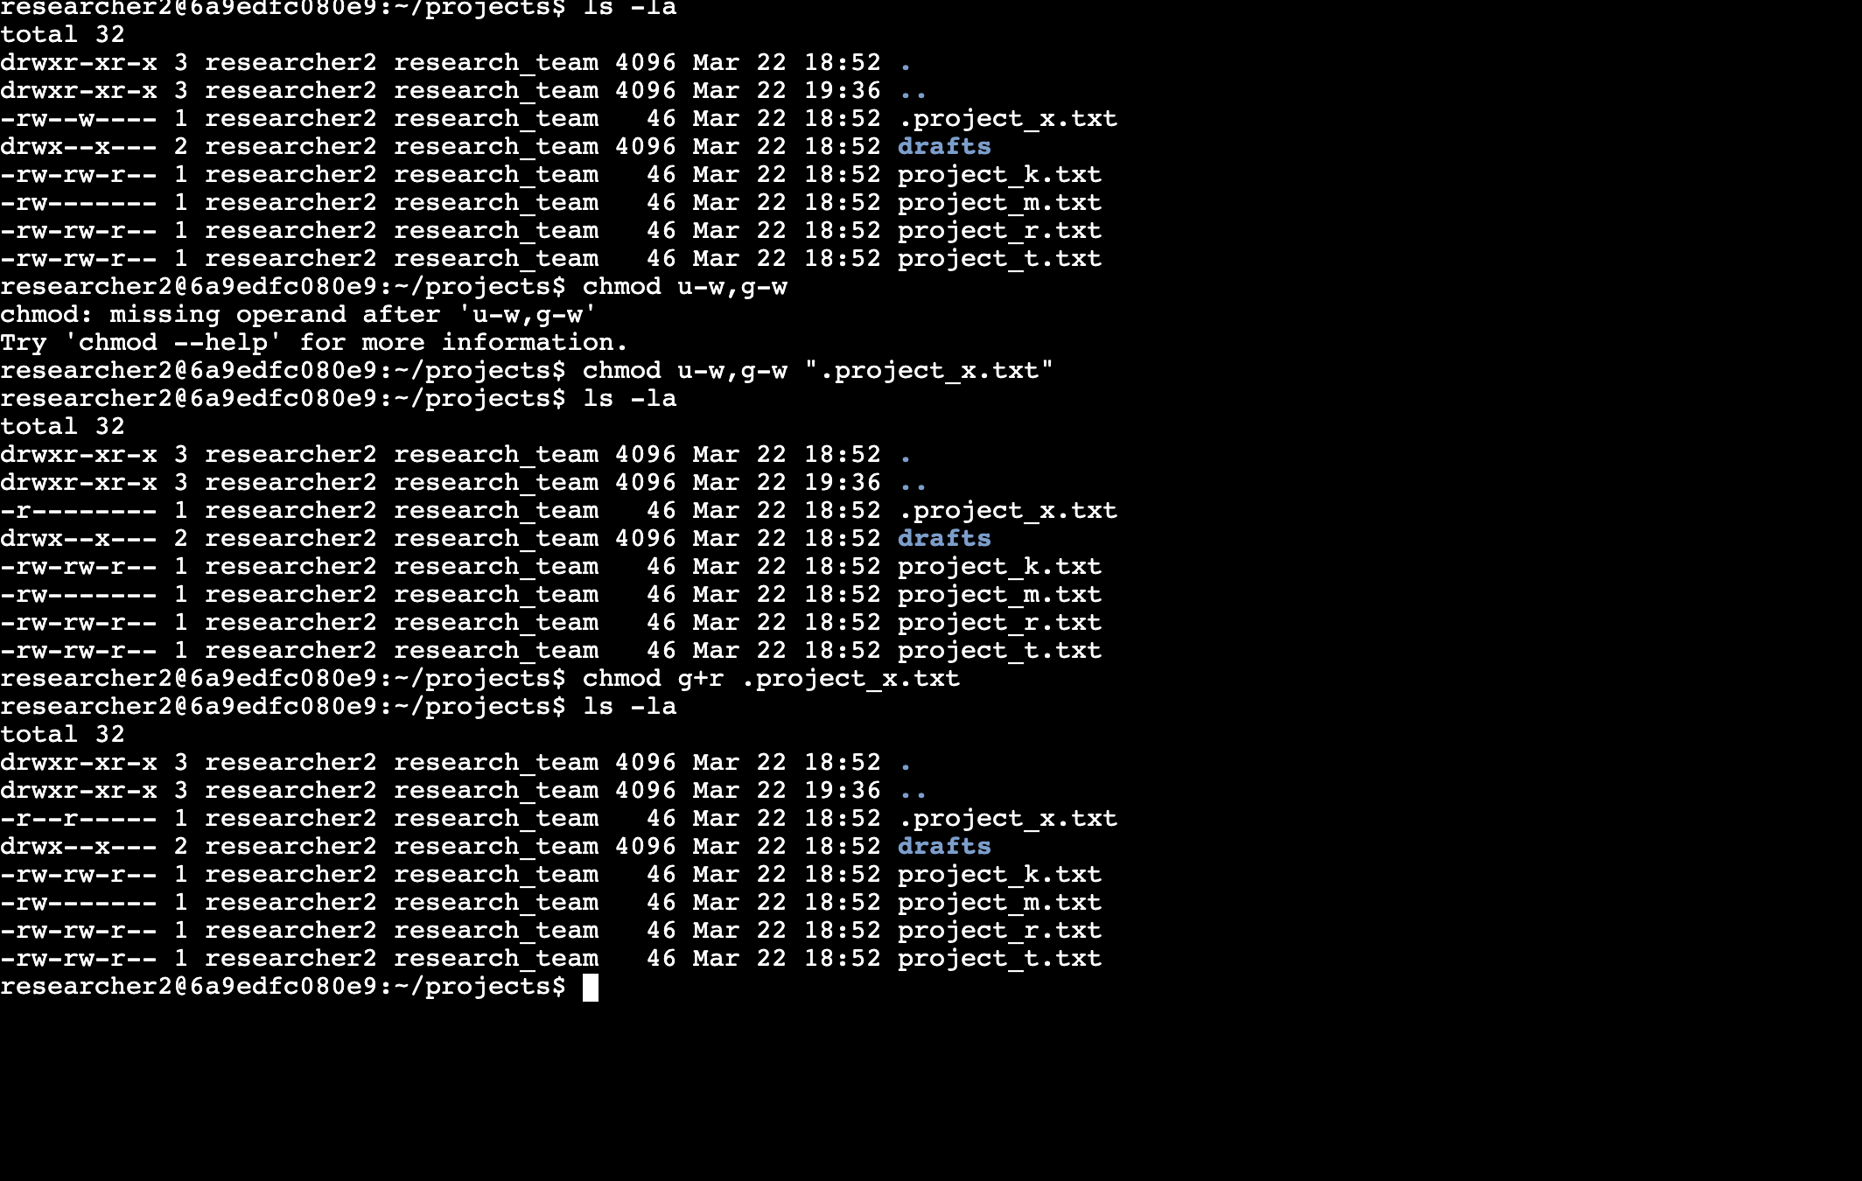

Figure 3

1. Now let’s change directory permissions. We’ll check the group permissions of the /home/researcher2/projects/drafts directory and then modify the permissions as required. => Only the researcher2 user should be allowed to access the drafts directory and its contents. (This means that only researcher2 should have execute privileges.)

Figure 4: using chmod to change the permissions of file directories

## Summary : what we did :

* We examined file and directory permissions,
* We changed permissions on files, and
* We changed permissions on directories.